|  |  |  |  |  |  |
| --- | --- | --- | --- | --- | --- |
| Date | 28-Nov-22 | | | Tester Name | Shahabuddin Syed |
| Environment | Penfax - Test | | | Login used |  |
| Operating System | Windows | Version: | Update: | | |
| Software Used | Edge | Version: | Update: | | |
| Select Software | Version: | Update: | | |
| Release version | 22.4.1 | | | | |
| Title |  | | | | |
| Test Type | Regression | | | | |
| Test Scenario | Process a spousal breakdown payment to a LIRA | | | | |
|  |  | | | | |
| Expected Results |  | | | | |
| Pass/Fail | Pass | | | JIRA# | N/A |

Describe your steps with screenshots:

Search for the member

Click on their stakeholder ID

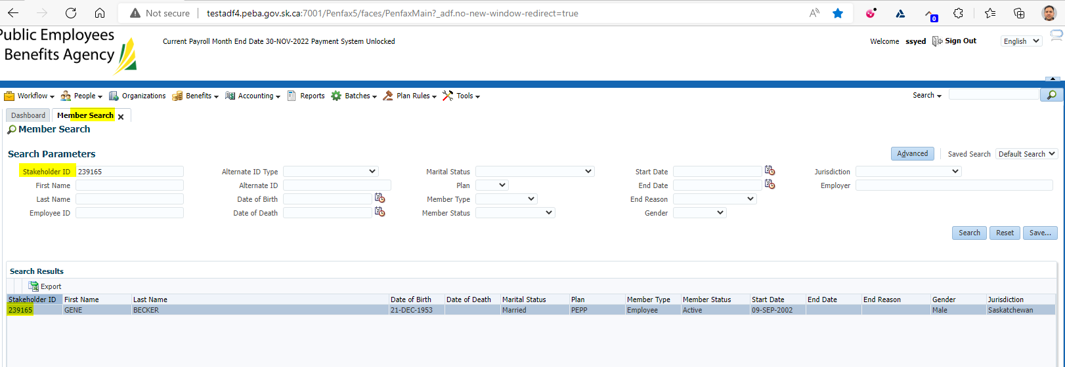

Click on DC SRB Claims

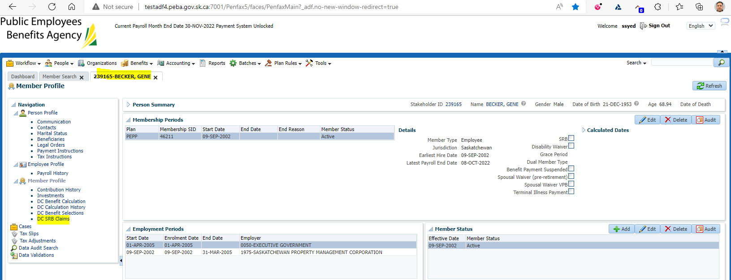

Click Add

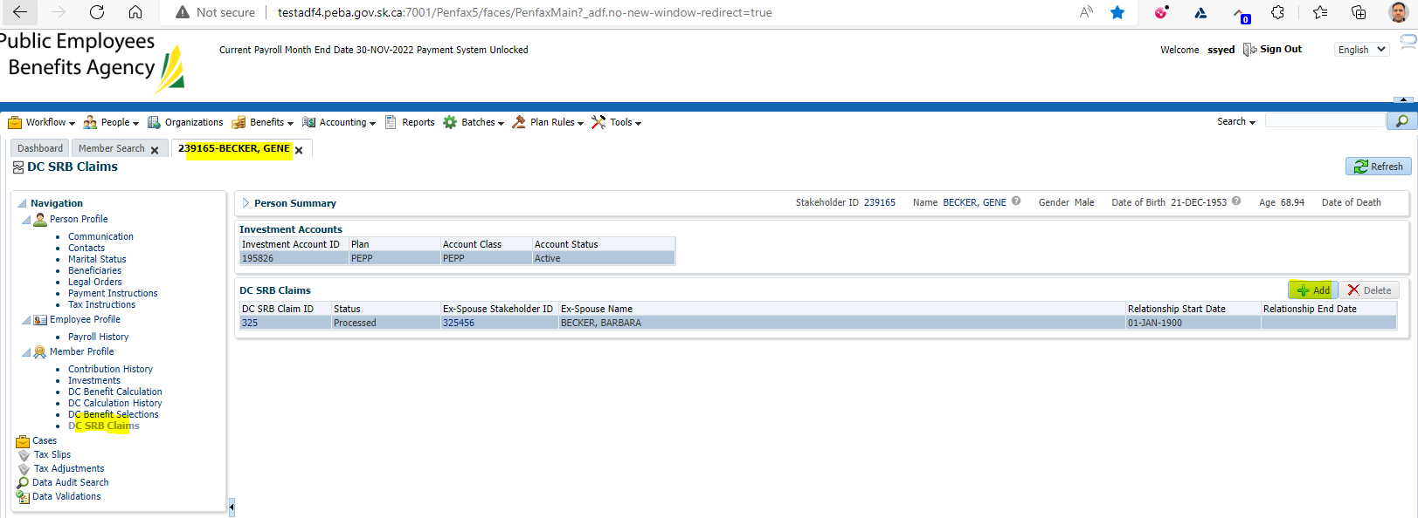

Make sure estimate Checkmark is removed

Click Save

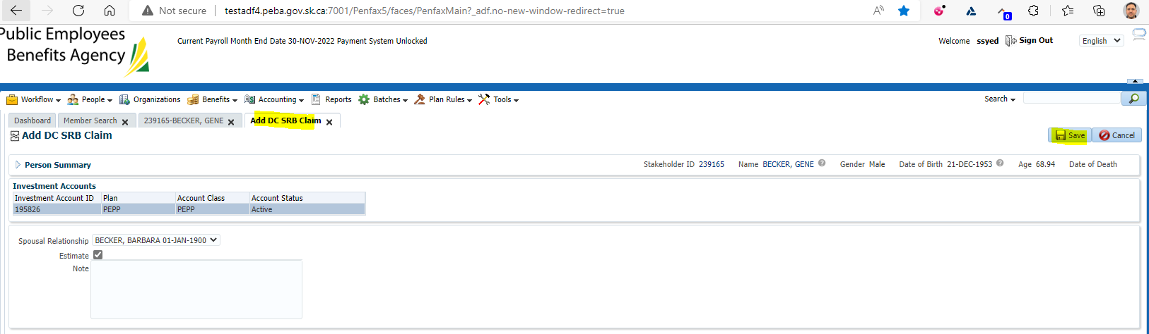

Under Method Select Share of Account with ROI

Input Claim percent as 50%

Change start date to be Jan 1, 2018

Change end date to current date

Click Calculate

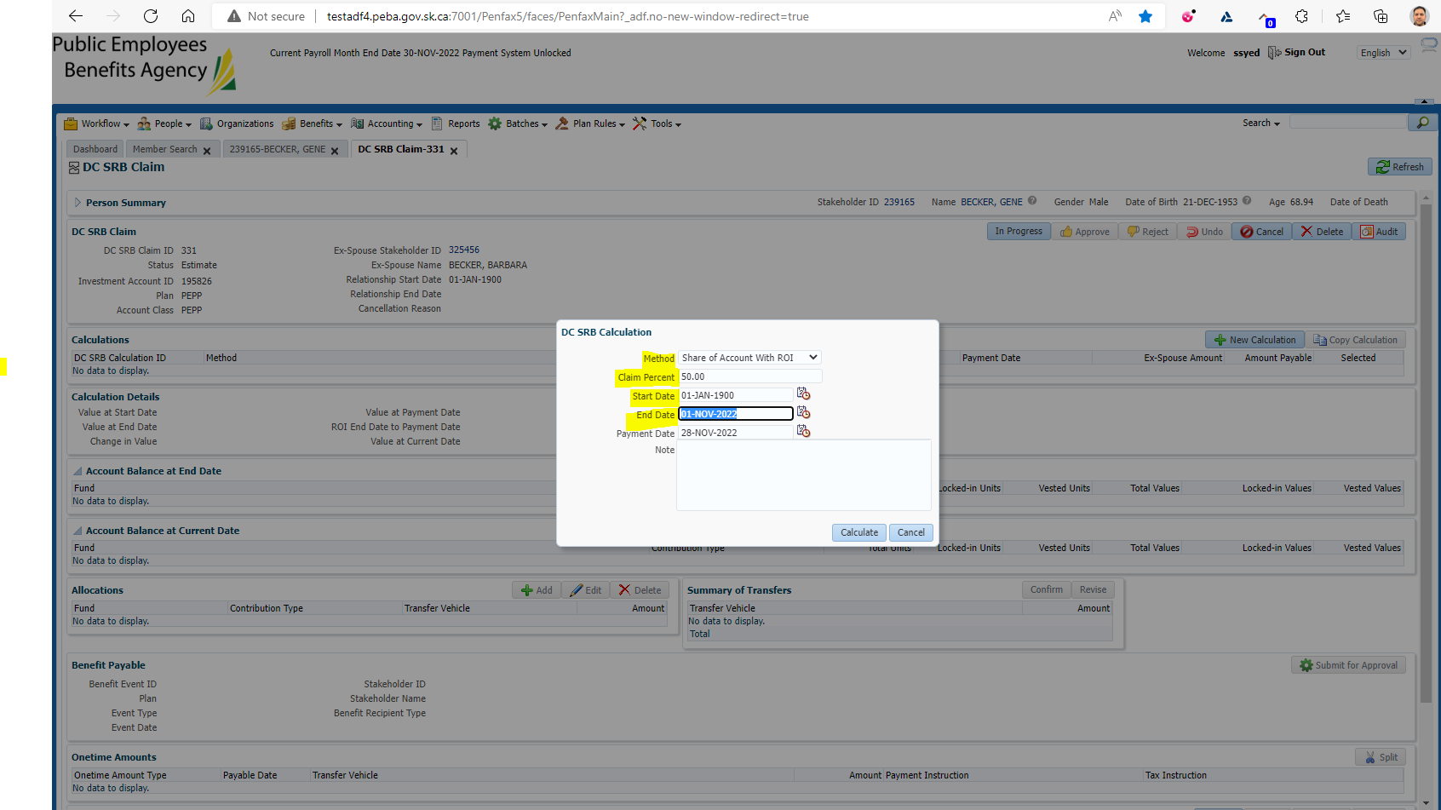

Under the Calculations you will see an Ex-spouse amount

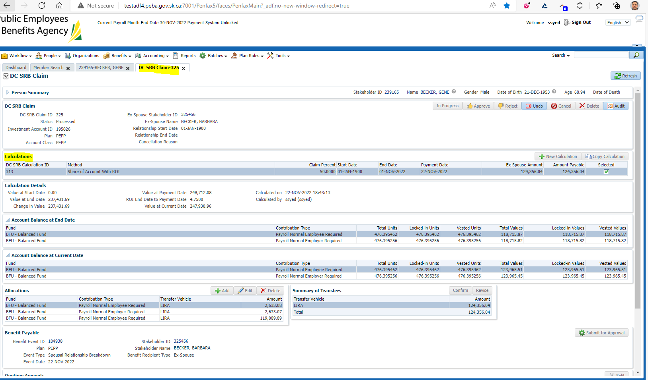

Under Allocations Click Add

Under Transfer vehicle select LIRA

Under amount input the Ex-Spouse Amount

Click Save

Under Summary of Allocations click Confirm

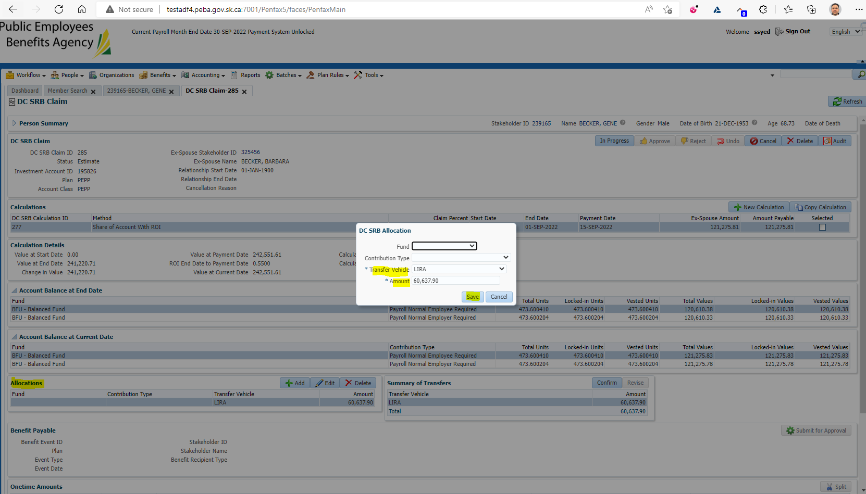

Under Summary of Allocations click Confirm

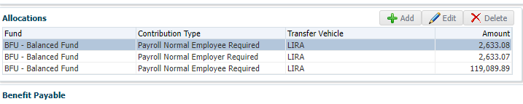

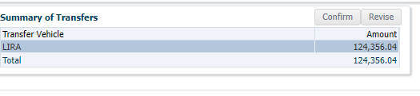

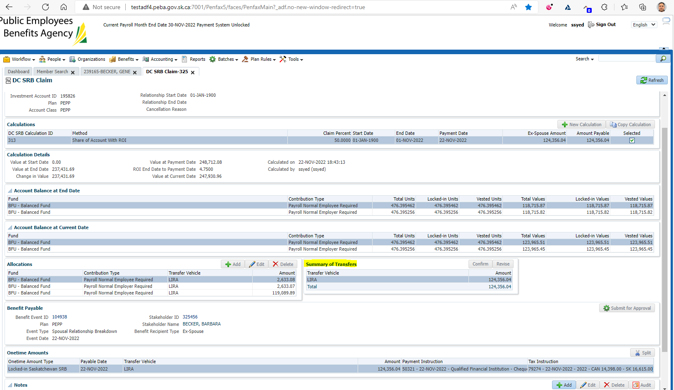

Under Onetime Amounts

Add a payment instruction

Add a tax instruction

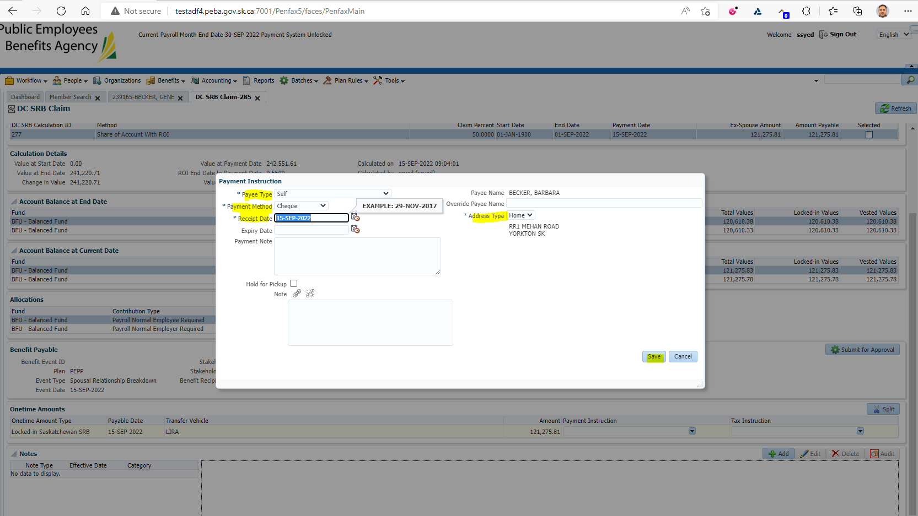

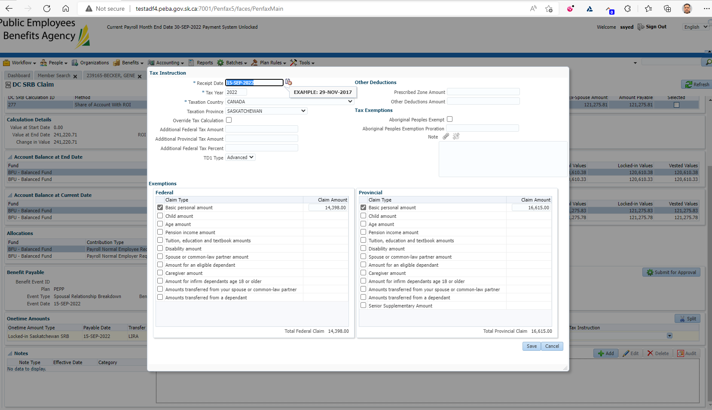

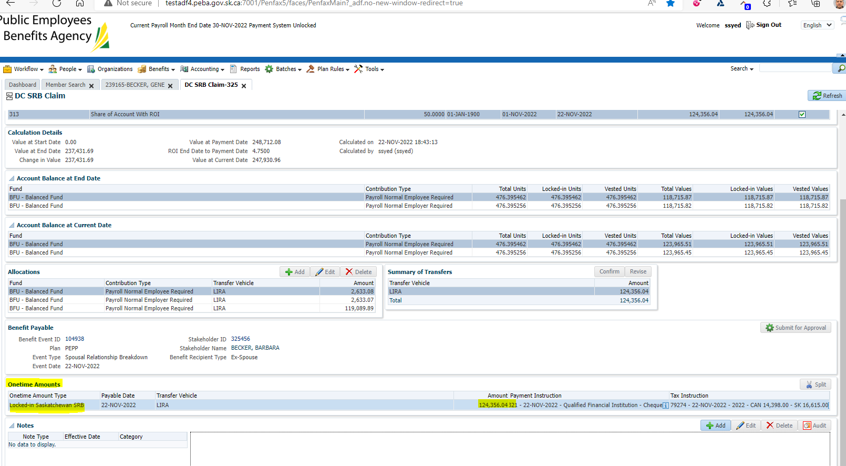

At the top of the screen under DC SRB Claim put In Progress

Click Submit for Approval

Approve the file

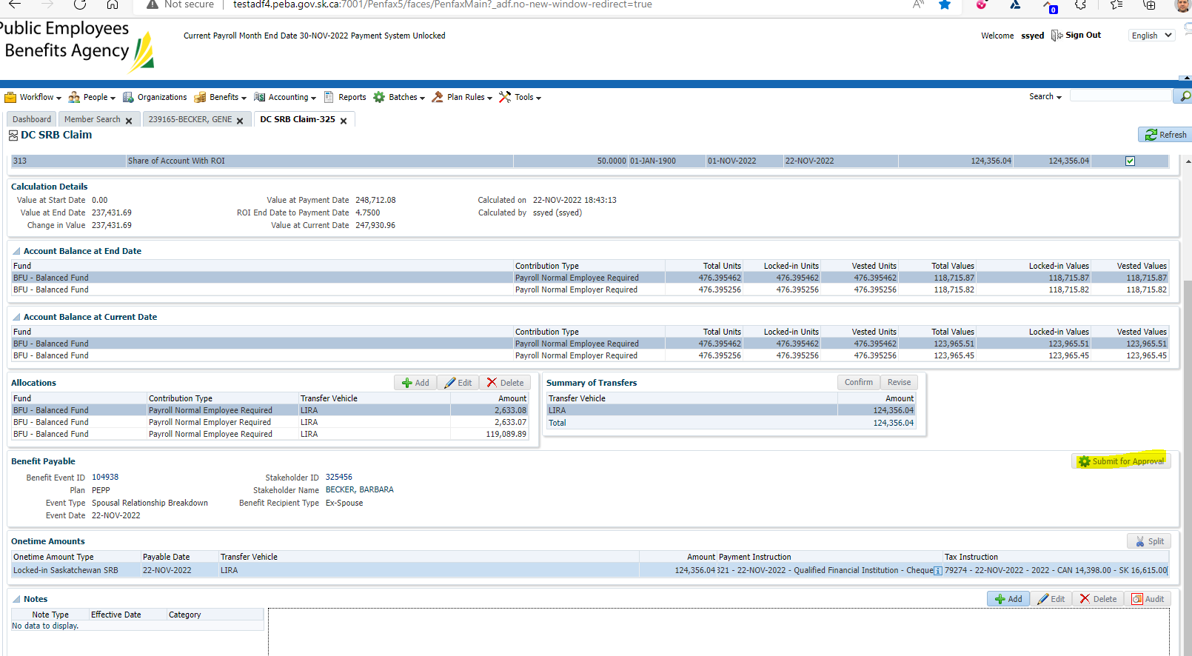

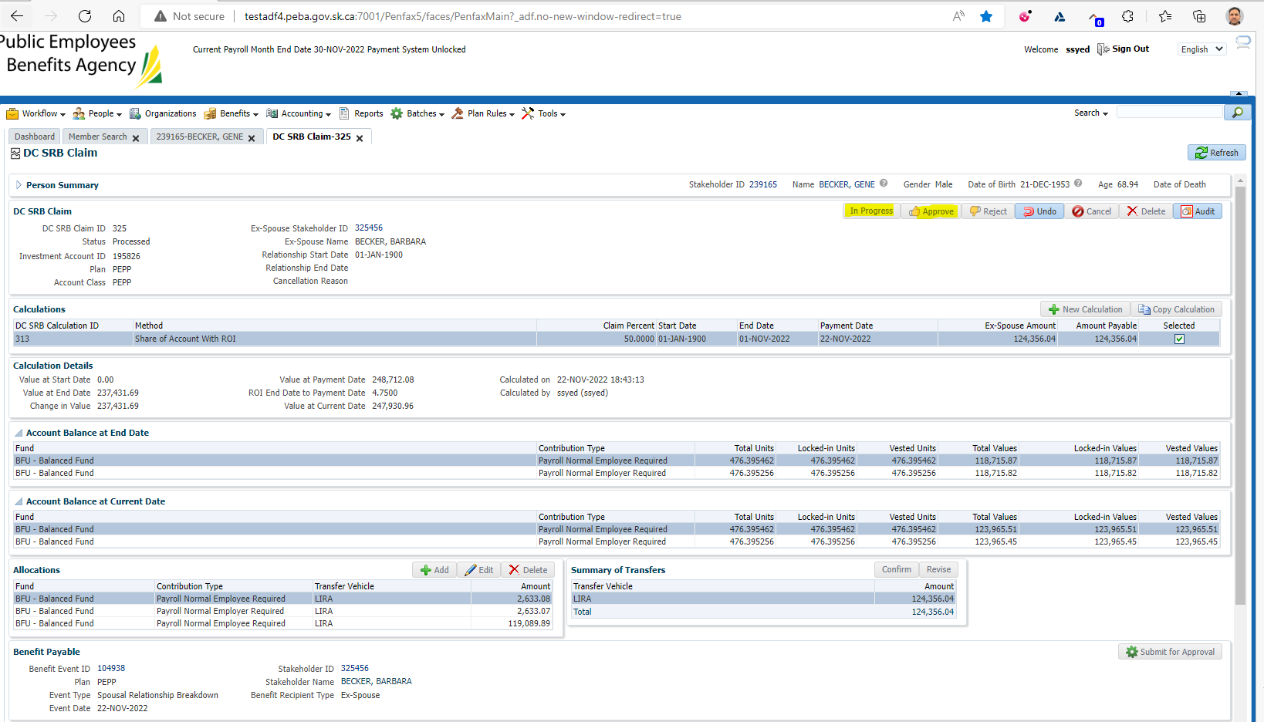

Wait for the overnight batches to run

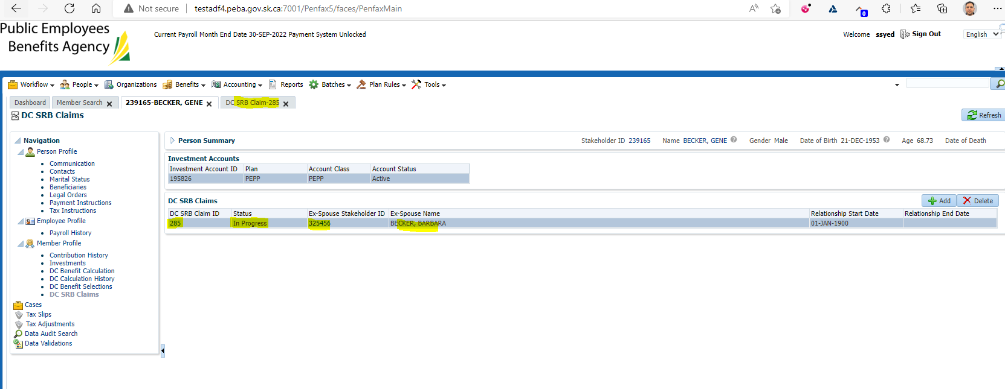

Verify the payment has been paid and that the cheque's were produced to the correct institution

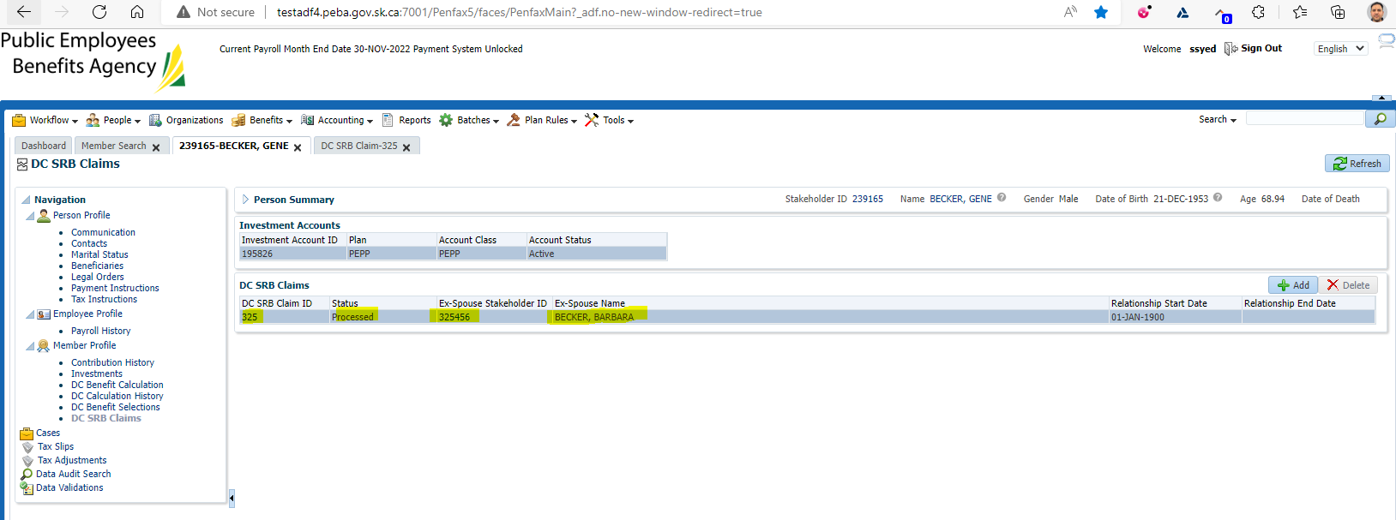

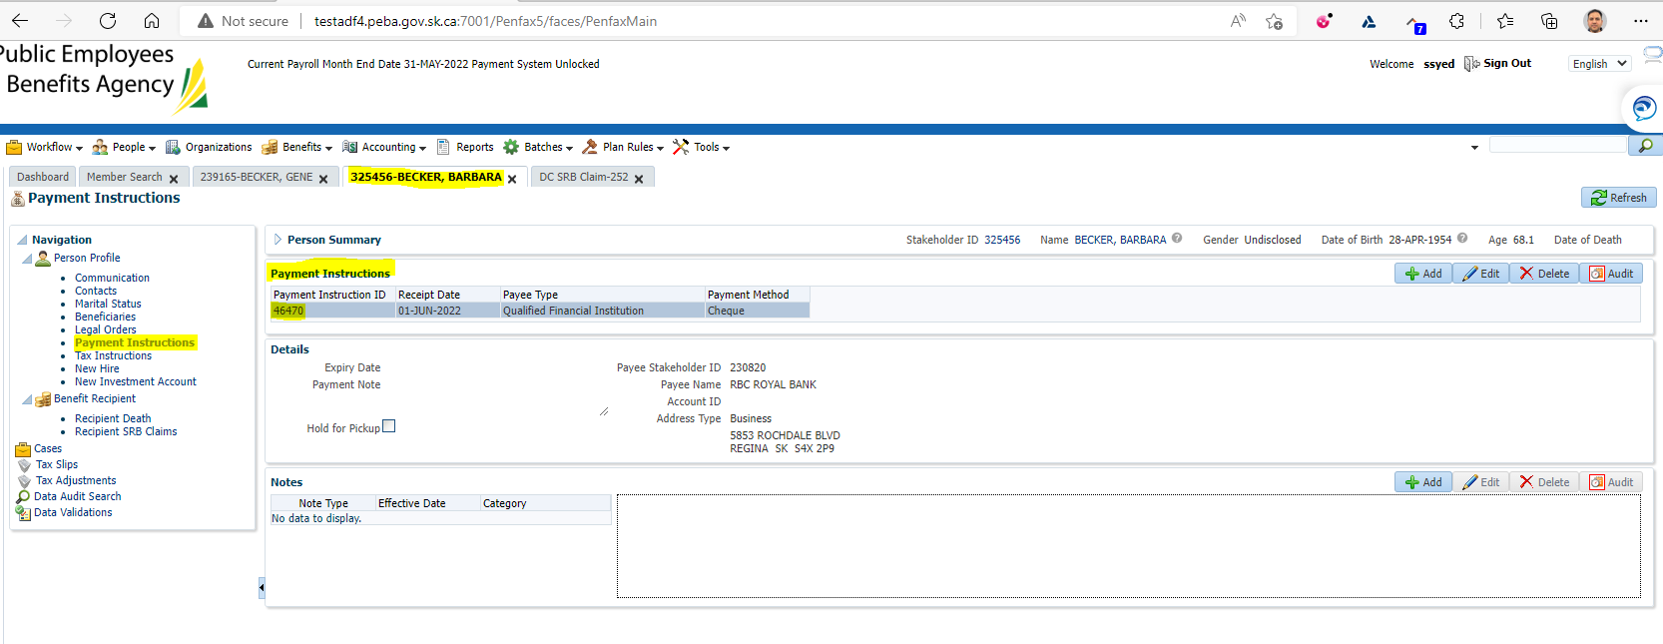

Verify that the Member Withdrawal Letter was produced for the member

Waiting for the letter to be generated

